Cornerstone Care Solutions Ltd

Corporate Business Continuity Plan

**1. Introduction**

The purpose of this Business Continuity Plan (BCP) is to prepare Cornerstone Care Solutions Ltd for potential disruptions, ensuring the continuity of operations, minimising financial loss, and safeguarding critical resources. This plan outlines a structured approach for crisis response, focusing on resilience and recovery.

**2. Objectives**

Maintain essential operations during and after disruptions.

Minimise impact on stakeholders, customers, employees, and reputation.

Facilitate a swift return to normal operations.

Comply with legal, regulatory, and contractual obligations.

**3. Scope**

This plan applies to all departments and functional areas within Cornerstone Care Solutions Ltd . The BCP includes protocols for dealing with the loss of personnel, facilities, systems, suppliers, and access to essential resources.

**4. Key Components**

4.1 Risk Assessment

Conduct a comprehensive risk assessment to identify vulnerabilities, prioritise potential threats, and prepare mitigation strategies. These risks include:

* Natural disasters (e.g., earthquakes, floods)
* Cybersecurity incidents (e.g., data breaches, ransomware)
* Facility-related disruptions (e.g., power outages, fires)
* Supply chain interruptions

4.2 Business Impact Analysis (BIA)

Identify critical business functions, their dependencies, and impact thresholds. Key elements to assess:

* Maximum Tolerable Downtime (MTD) for critical functions
* Recovery Time Objectives (RTO) and Recovery Point Objectives (RPO)
* Resources required to sustain essential functions

Risk Matrix

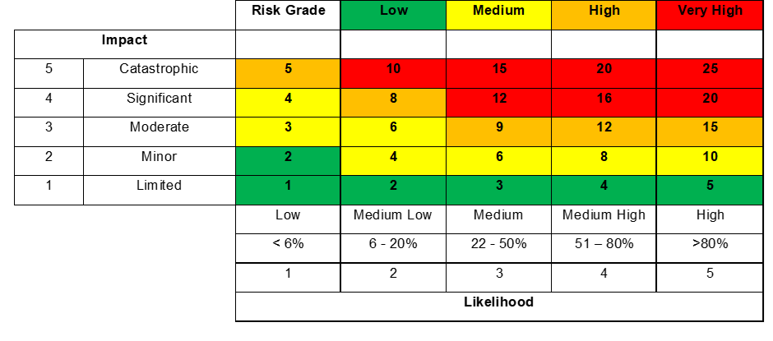

**5. Incident Management and Communication**

5.1 Incident Response Team (IRT)

Establish an Incident Response Team with clear roles and responsibilities for implementing the BCP. Key positions:

* **Incident Manager:** Leads response efforts, assesses the situation, and activates the BCP.
* **Incident Coordinator:** Ensures essential functions continue with minimal disruption.
* **Communications Lead**: Manages all internal and external communications.

**5.2 Communication Plan**

Develop communication protocols to keep stakeholders informed. Channels include:

* Internal: Email alerts, internal messaging systems, or phone trees
* External: Company website, press releases, and social media

**6. Business Continuity Strategies**

|  |  |  |  |  |  |
| --- | --- | --- | --- | --- | --- |
|  | Impact x  Likelihood = Risk Grade | | |  |  |
| **Threat Area** | **I** | **L** | **Grade** | **Control Measures** | **People Responsible & Furter Actions** |
| Staffing and Human Resources | 4 | 3 | 12 | **Cross-training:** Train staff across departments to handle essential functions.  **Emergency staffing:** Identify back-up staff for critical roles and establish remote work options if access to facilities is compromised.  **Emergency Recruitment Partnerships:** Establish partnerships with staffing agencies for immediate access to temporary staff during crises.  **Flexible Hiring Practices:** Implement expedited hiring and credentialing processes to fill essential roles quickly. | Recruitment and Retention Manager/Home Managers/Regional Managers/Central Management Team |
| Facility and Infrastructure Recovery | 4 | 1 | 4 | **Alternate Sites:** Arrange for alternate sites to be used if primary facilities are unavailable.  **Remote Access:** Implement systems that allow critical staff to work remotely and securely. | Operations Director/Director of Asset Management |
| Technology and Data Backup | 4 | 2 | 8 | **Data Backups:** Regularly back up data to secure off-site locations.  **IT Redundancy:** Maintain redundancy for critical IT systems to ensure operational continuity.  **Cybersecurity Measures:** Implement robust cybersecurity protocols to protect sensitive data and systems. | Commercial Manager/DIS contractors |
| Supplier and Vendor Continuity | 3 | 3 | 9 | **Alternative Suppliers:** Maintain relationships with backup suppliers to ensure availability of essential materials.  **Service Level Agreements (SLAs):** Regularly review SLAs with critical vendors to confirm their BCPs align with Cornerstone Care Solutions Ltd 's requirements. | Director of Asset Management/Operations Director/Financial Controller |
| Care Delivery | 4 | 3 | 12 | **Continuity of Care Plans:** Maintain detailed care plans for each resident to ensure seamless transitions and continuity of care during disruptions.  **Backup Health Providers:** Develop partnerships with other care providers for immediate assistance in case of an emergency. | Home Managers/Regional Managers/Operations Director |
| Health & Safety | 4 | 2 | 8 | **Risk Assessments:** Conduct regular health and safety risk assessments to ensure compliance with Health and Safety Executive (HSE) standards.  **Emergency Response Plans:** Develop clear emergency response protocols for fire, flood, and other potential hazards within facilities. | Operations Director/Director of Asset Management/Regional Managers/Home Managers |
| Liquidity & Cash Flow | 5 | 2 | 10 | **Cash Flow Forecasting:** Maintain updated cash flow forecasts to anticipate potential financial strains.  **Contingency Funds:** Set aside contingency funds for use during unexpected financial disruptions. | Chief Financial Officer/Financial Controller |
| Profitability | 5 | 2 | 10 | **Expense Monitoring:** Closely monitor and control expenses during periods of reduced income to maintain profitability.  **Revenue Diversification:** Identify and pursue alternative revenue streams to mitigate risks related to specific income sources. | Chief Financial Officer/Financial Controller |
| Asset Management | 4 | 2 | 8 | **Asset Inventory:** Keep a comprehensive and updated inventory of assets, with specific plans for asset protection during emergencies.  **Maintenance Scheduling:** Maintain regular inspection and maintenance schedules to prolong asset life and prevent unexpected failures. | Director of Asset Management/Operations Director |
| Brand and Public Perception | 4 | 2 | 8 | **Crisis Communication Strategy:** Develop a communication plan to manage public perception, providing timely updates on Cornerstone Care Solutions Ltd ’s response during incidents.  **Media Training:** Train key executives and communication leads on managing media inquiries and maintaining brand integrity. | Marketing Manager/Operations Director |
| Regulatory Compliance | 4 | 3 | 12 | **Continuous Monitoring:** Regularly review and update policies to ensure compliance with regulators such as CQC, HSE, and other local authorities.  **Compliance Audits:** Conduct regular internal audits to identify and rectify compliance gaps promptly. | Operations Director/Director of Asset Management/Regional Managers/Home Managers |
| Economic Climate | 4 | 1 | 4 | **Financial Resilience Planning:** Assess economic risks and create financial resilience plans, including cost-cutting measures if required.  **Scenario Planning:** Regularly evaluate the impact of economic downturns on Cornerstone Care Solutions Ltd ’s operations, adjusting plans as necessary. | CEO/Standards Manager |
| Pandemics and Natural Disasters | 4 | 1 | 4 | **Pandemic Response Plan:** Maintain a pandemic response plan, including PPE stockpiling, vaccination support, and isolation protocols.  **Disaster Preparedness:** Develop preparedness measures for natural disasters, such as flood defenses, backup generators, and evacuation plans. | CEO/Standards Manager |

**7. Testing and Maintenance**

7.1 Testing

Conduct regular drills and simulations to ensure executive team preparedness. Types of testing:

* Tabletop exercises: Scenario-based discussions to test response plans.
* Functional drills: Testing specific BCP components, such as remote access or data recovery.

7.2 Plan Review and Update

The BCP should be reviewed and updated at least annually or after any major business or operational change.

**8. Training and Awareness**

All Senior Management within Cornerstone Care Solutions Ltd should receive regular BCP training to understand their roles and responsibilities in a crisis. Include BCP elements in induction and conduct a refresher annually.

**9. Plan Activation and Deactivation**

Activation: The Incident Manager, upon assessing a disruption, may activate the BCP to address critical business functions.

Deactivation: Once normal operations can resume, the Incident Manager will formally deactivate the BCP.

**10. Plan Governance**

Cornerstone Care Solutions Ltd Executive Team is responsible for the governance and oversight of the BCP, ensuring continuous alignment with business objectives and requirements.

|  |  |  |
| --- | --- | --- |
| **Review Date** | **Reviewed By** | **Sign** |
|  |  |  |
|  |  |  |
|  |  |  |
|  |  |  |